Malaysian Journal ofScience 17B: 65-68 (1996)
On the South China Sea numerical model
Alejandro Camerlengo and Monica Ines Demmler
Faculty of Fisheries and Marine Science, Universiti Pertanian Malaysia Terengganu, Mengabang Telipot, 21030 Kuala Terengganu, Malaysia

ABSTRACT This study reports the important characteristics of the South China Sea numerical model. A new algorithm is implemented as the original model has closed, open and periodic boundary conditions.
ABSTRAK Tujuan kajian ini adalah untuk melaporkan ciri-ciri penting model numerikal Laut China Selatan. Algorithma baru telah dilaksanakan kerana model asal mempunyai syarat-syarat sempadan yang terbuka, tertutup dan berjangka.

INTRODUCTION
We have developed a hydrodynamic, vertically integrated, numerical model of the South China Sea (SCS) for predicting the circulation off Peninsular Malaysia's eastern coast during the north-east and the south-west monsoon seasons[1-3]. The model has the capability of using either closed, periodic or open boundary conditions. These boundary conditiot\s are activated by different logical "switch". A staggered grid in space is used; the particular staggering of the grid makes the prognostic variables (u, v and n) take variable dimensions. We report a new method of implementing different boundary conditions.
THE SOUTH CHINA SEA MODEL

Model Equations
The SCS model solves the vertically integrated, barotropic mode. The Boussinesq approximation and the hydrostatic pressure in the vertical are assumed. The model equations are the classical hydrodynamic equations of conservation of mass and momentum.
The equations for the external mode are
ðv / at + V. VV +fKxV = -gVTl+(rw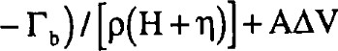 (1)
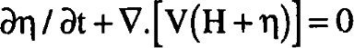 (2) where V represents the eulerian velocity vector. Its eastwest and north-south velocity components, u and v, correspond to the horizontal derivatives x and y (positive in the east and north direction, respectively); V, the horizontal gradient; A, the Laplacian operator; H, the mean depth; f, the Coriolis parameter; g, the gravity' s acceleration; r , the shear wind stress; rb, the bottom friction; K, the vertical normal vector; p, the water density; n, the free surface elevation; A, the horizontal coefficient of eddy viscosity; and x (J, the vectorial (scalar) multiplication.

Horizontal Stretch Coordinate
The x and y coordinates systems are transformed into a new coordinate system.
s(x) = a [ 01 x + tanh { (x — Xk)/ Yk } + b ] (3)
where 01 represent the slope of the curve; the constants a and b are chosen in such a way that:
s ( 0 ) = 0 and s ( 1 ) — 1 (4)
In Eq. (3), we have a combination of a straight line (given by (1 x), an ordinate to the origin (given by b), and a stretching (given by the hyperbolic tangent). Any variable q (u, v or n) may then be derived as
ðq / ax = (ðq / ðs)(ðs / ðx) (5) ð²q / ax² = (ð²q / / ðx)² +(ð²s / ðx² / ðs) (6)
Given, for example, the equation ðq / ðt + u(ðq / ðx) = A(ð²q / ðx² ) (7) yields ðq / ðt + / / ðx)] = 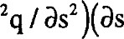/ ðx)² +(ð²s / 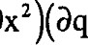/ ðs)]
(8)
Given the appropriate choice of ^{A}h, we may obtain either a regular or an irregular grid spacing in either direction [4] •
Boundary Conditions
Closed, periodic and open boundary conditions are implemented in the original numerical model.
Closed boundary conditions may either be free-slip or non-slip. Under the latter conditions, both the normal and the tangential velocities are set to be zero at the wall; under the former conditions, both the normal velocity as well as the normal derivative of the tangential velocity are set to be zero at the solid wall.
Periodic boundary conditions, also known as "wraparound" conditions in general circulation models, are defined (in the x direction)
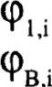
= (PB_I I

= 921 (9b)
where (P represent any variable; and the subscript B, the boundary grid point. Similar conditions of periodicity may be defined in the y-direction.
Open Boundary Condition. It is defined as an (artificial) computational boundary that allows the outflow of all phenomenon generated in the interior domain. No contamination of the interior solution will take place.
The OBC implemented is of the Sommerfield radiative type, which is
/ ðt + / ðx = 0 (10)
where c represents the phase velocity of any particular variable (P (u,v, or n).
Eq. (10) is used twice. In the first case, for the purpose of determining whether the flow is trying to go in or out of the domain of integration, the phase velocity at grid point B — 1, at time step j, is determined from
B—2j—l / Ax (l l)
Upon evaluation of c , (PB^{J}+ ^{I} is determined using equation (10) from
(PBj+l — (PBJ_t —(C At / Ax 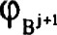+(PBj-l —29B_v (12)
The behavior of eleven open boundary conditions
has been addressed [5]. The OBC defined as ORE, MORE, ORI and MORI, are implemented in the numerical model. For a more detailed explanation of the type of the four OBC been implemented in the model, the reader is referred to Ref. [5].
A new technique for the implementation of closed, periodic and open boundary conditions The model is designed using an Arakawa C grid. In this particular grid, the free surface elevation is evaluated at the center of the grid, whereas u is calculated in the east and west sides, and v at the north and south sides
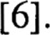
Owing to the particular grid been used, the dimensions of u, v and are variable. For this purpose, a new algorithm has been implemented. In the north-south direction, y, the variable distribution is as follows:
1M
1M
IM-I
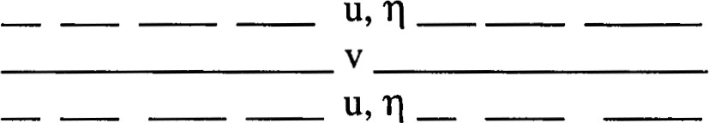
2
1
1
Figure 1. Implementation of u, v, and in the north-south direction in the numerical model.
where the v interior grid points are evaluated from i = 2 to i = 1M — 1B, and the interior grid points for u and from i = 2 to i = 1M — 1. represents the boundary grid point for u and in the north-south, y, direction.
If one chooses to implement a periodic boundary condition, 1B is set to be 1. On the other hand, if the chosen boundary condition is either open or a solid wall, 1B is set to be 2. Therefore, open or closed boundary conditions, for u and n, are evaluated at i = 1 and i = 1M. For v, the boundary conditions are calculated at i = 1 and i = 1M + 1 -1B.
The dimensions for u and n, in the y direction, are 1M whereas for V the dimensions in the y-direction are
1M + 1 — 1B. If periodic boundary conditions are chosen, the dimension of V is 1M; otherwise, it is 1M — 1.
The same procedure is followed in the east-west, x, direction. In this particular case, v and has a dimen-
sion IN, where IN represents the boundary grid point in the x direction. If periodic boundary conditions are implemented, the dimension of u is IN; otherwise, its dimension is IN — 1.
Computational Mode
Because of the fact that a leapfrog scheme is used, two waves appear in the numerical solution [7]. Of these two, only one solution is real. This solution is known as the computational mode. There are many schemes one can choose to eliminate this computational mode. What follows is the particular scheme we have chosen to eliminate the computational mode.
Let us consider the advective equation
(13)
where c represents the phase speed and K any variable. The initial condition is given by
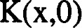= H exp ( i v x (14)
where H represents an arbitrary constant; v ( = 27t/ L), the wavenumber; and L, the respective wavelength.
Eq. (13) is solved by the method of separation of variables.
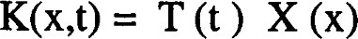 (15)
Upon substitution of (15) into (13), the equation yields
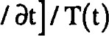— ax]/ X(x) = const.= —q (16)
Upon integration of Eq. (16),
T = DI exp (— q t ) (17a)
X = exp (q x/c) (17b)
where D and D are arbitrary constants. After some algebraic manipulation of Eqs. (14) and (17),
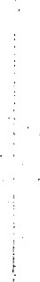
q=ivc (18)
K ( x, H exp [ i v ( x - c t)] (19)
Given an arbitrary initial condition
(20) the general solution is of the form
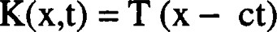 (21)
Thus, the solution K has the same value at each coordinate point (x, t) that satisfies the relation
x — c t constant = d (22)
and K = T (d) at these particular points. The straight lines (22) in the (x,t) plane, having a slope c-l , are the characteristics of Eq. (13). The solution prop ates along these curves.
A numerical solution is sought. Let
x=kAx, k = 0, ± (23a)
t =j At, j = 0, 1,2 (23b)
A second order in space and time finite difference formulation of Eq. (13) yields

K ^{j}+^{l} - Kk^{j}- ^{l} = -K ^{j} ) (24)
where y = (c A t)/ A x. Eq. (24) has three time levels. Eq. (24) is solved analytically by the method of separation of variables.
K ^{j} = 'P exp (iv kAx) (25)
where T may be complex. Upon substitution of Eq. (25) in Eq. (24) yields
[T — T^{l}] exp (i v k A x) = —Y{exp [i v (k + l) A x) —exp (iv(k—l) Ax])
(26)
Multiplying Eq. (26) by T yields
T2 +2iQT - 1 =O (27)
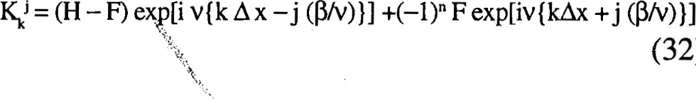
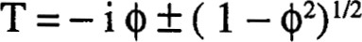 (28)
(32)
where (þ = y sin (VA x). TWO complex conjugate solu- small, Eq. (29) yields: = c v A t. In (34) the exponen- tions are obtained. Namely tial factor of the first wave becomes exp[i v(x — c t)]. Let A t —¥ 0. This gives Z = 1 and W = O. The first wave
K ⁰ = (N + F) exp (i v k A x) = H exp (i v k A x)  Let H = N + F. Given the fact that exp (i It) (30) yields | (31)  1 Eq
A stable solution is obtained whenever 1 [8].
If (1 — 0²) 0, two solutions are obtained
T+ = exp (— i P) = 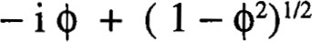
T_ = exp (i It) = —i 0— ( 1 —0 ) (29)
where = sin-I Q. The solution of Eq. (25) yields
Kk^{J} = [N exp (—ij P) + F exp {i (P + It) j}] exp (i v k A x) (30)
where N and F are arbitrary constants. If j is set to be zero,
The analytic solution of Eq. (13) is represented by one wave, the numerical solutions of this same equation consist of two waves because the finite difference for-
mulation is of second order.  After some algebraic manipulations, |  | REFERENCES
F: -H [1 - cos [2 cos P] (33) | 1 | Camerlengo, A. L. and M. I. Demmler (1996) Pertanika J. Sci. & Technol., 4: 111.
Substitution of (33) into (32) gives | 2 | Camerlengo, A. L. and M. I. Demmler (1995) Malays. J. Sci., 16B: 95.
 | 3 | Wyrtki, K. (1961 )Physical Oceanography of the Southeast Asian
K ^{j} = (H {kAx-j(ß/v) |  | Waters. NAGA report, vol.2. University of California, La Jolla,
(34) |  | USA, 195 pp.
 | 4 | Camerlengo, A. L. (1982) Phys. Oceanogr. 12: 1106.
 | 5 | Chapman, D. C. (1985) Phys. Oceanogr. 15: 1060.
where | 6 | Arakawa A. and V. Lamb (1977) Computational Design of the UCLA General Circulation Model. Methods of Computational
z = (1 + cos P], (35a) |  | Physics., Academic Press, New York.
 | 7 | Haltiner G. J. and R. T. Williams (1980) Numerical Prediction
 |  | and Dynamic Meteorology. John Wiley & Sons, 470 pp.
w = [1 - cos [2 cos P] (35b) | 8 | Mesinger F. and A. Arakawa (1976) Numerical Methods Used in Atmospheric Models. Volume 1. GARP Publications Series
As A x —¥ 0, 4) = c v A t, following (27). Then for A t |  | No. 17, 64 pp.
or mode in (34) approaches the real solution, whereas the second mode vanishes. The former mode is known as the physical mode, and the latter the computational mode. This mode is a spurious one. It chànges sign every time-step and travels in the opposite dií•ection to the physical mode.
One way to elinfrlate the computational mode is to intercalate a two-level scheme every N time-step. There are several two-level schemes one can choose. The particular scheme been implemented in the model is an Euler-backward scheme. Briefly, a first step using the Euler scheme is made, in the following manner:
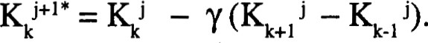(36)
This approximate value, Kk^{J}+^{l} * , is then used to make a backward step:
K ^{j}+^{l} -Y(Kk - Kk_ ^{j}*). (37)
This same scheme is also used to calculate the first time step. This scheme is evaluated only every N (odd) time steps.
Acknowledgements This research was financially supported by UPM in its entirety. The authors gratefully acknowledge this support.

