Malaysian Journal of Science ISA: 35-37 (1994)
The decomposition and N mineralization ofAzolla pinnata in moist and flooded soil
H. F. Tung
Department of Botany, University of Malaya, 59100 Kuala Lumpur, Malaysia

ABSTRACT Thedecomposition andN mineralization offresh and dried fronds of a local of Azolla pinnata were monitored in moist and flooded soils. Results show that nitrogen in the fem can be readily converted and released into the soil as Although the rate of N release is more rapid in fronds with a higher water content, the total amount of N released under flooded condiüons is greater in dried than in fresh samples. Basal application of both fresh and dried Azolla can effectively replace the application of inorganic N in rice cultivation.
ABSTRAK Pereputan dan pemineralan N fron segar dan kering dari satu strain paku pakis tempatan Azolla pinnata telah dikaji dalam tanah lembab dan tanah limpah air. Keputusan yang diperolehi menunjukkan bahawa kandungan nitrogen dalam paku pakis ini dapat ditukar dengan cepat serta dilepaskan ke dalam tanah sebagai N-ammonium. Walaupun kadar pelepasan N dari fron segar lebih tinggi jika dibandingkan dengan fron yang telah dikeringkan,jumlah N yang dibebaskan di bawah keadaan tanah limpah air adalah lebih banyak dari fron kontang berbanding dari fron segar. Pembajaan tanah dengan Azolla segar atau kering boleh menggantikan secara berkesan penggunaan baja N bukan organan dalam penanaman pokok padi.
(Azolla, decomposition, biQfertilizer, rice yield)

NTRODUCTION
The use ofAzolla as a green manure to increase yield in rice cultivation is well documented [1, 2, 3, 4]. The fem is generally incorporated as a basal fenilizer into the soil priorto sowing or transplanting of rice. As such, studies on the decomposition of Azolla, the release and availability of its N to rice plants are pertinent and indeed essenüal ifit is to be used effectively in rice cultivation. The few reports on the decomposition of Azolla have shown that N release from the fem is not only species dependent but also influenced by the physiological state of the plants and conditions of the soil [5, 6].

This study presents a comparative analysis of the decomposition and N mineralization of a local strain of A. pinnata in three physiological states viz (i) green, vigorously-growing, (ii) red, slow-growing, and (iii) dried fronds of healthy greenAzolla plants under moist and flooded soil conditions.

MATERIALS AND NŒTHODS
The decomposition and N mineralization of a local strain ofAzolla pinnata in three different physiological states were studied over a period of 50-60 days in moist (60% water content) and in flooded soil. Healthy green plants (94.4% water content, 3.87% total N based on dry matter) used in this study were cultured in a standard N-free medium in the greenhouse while the red, slow-growing fronds (90.9% water content and 2.21 % total N) were propagated in nutrient-poor floodwater under natural temperature and light conditions. Dried Azolla (4.78% total N) were obtained by drying the green plants to constant weight at 80⁰C.
Azolla plants were mixed with soil obtained from a rice field in Tanjong Karang at a ratio of 2 g fresh weight ofplant sample to 30 g air-dried soil. On the other hand,
driedAzolla were mixed in a ratio of0.2g to 30 g of the same soil (pH = 5.0, N = 0.17%, organic C = 1.15% and water holding capacity = 53.1%). Incubation of the plant-soil mixture was carried out at 30C in the dark and soil samples withoutAzolla served as controls. Ammonium- and nitrite-N were determined by the method of Bremmer [7] while nitrate-N was assayed using the spectrophotometric method of Cawse [8].
To monitor the effect of basal application ofAzolla on growth and yield of rice, plants of Oryza sativa L. cultivar MR 84 were grown in cement tanks as described previously [9]. The Azolla plants were incorporated as one basal supplement a day prior to transplanting of the rice plants or in 2-3 split applications, viz one day before transplanting, at weeks 4-5 and at week 1 1 when panicle initiation occurred. Control tanks planted with rice only were fertilized with (NH4)2S04.  and KCI. Details of fertilization are given at the appropriate sections in the results.
At weekly intervals, the height of the rice plants and the number of tillers perhill were recorded. To estimate the yield, the grain, and straw of the middle four plants of the two inner rows were harvested and the dry weight determined.

RESULTS AND DISCUSSION
Results show that during the decomposition of the three differentAzolla samples in moist and flooded soil, the N released was mainly in the form of NH4-N and only small amounts of N03-N, between 5-6% and less than 1 % of the total N content of the fem were released from fresh and dried fronds respectively (Figs. 1, 2 and 3). Little or negligible amounts of N02-N were measured.
Comparing the extent of N mineralization of the three Azolla samples, it was observed that comparable rates of NH4-N release occurred in flooded and in moist soil for both the fresh fem samples with the release being more rapid in the green than in the red Azolla plants (Figs. 1 and 2). This may be a consequence ofthe softer tissues and higher water content of the vigorously-growing green plants. The maximum amount of NH4-N released was around 30% of total N which is much lower than the 62-75% reported by Watanabe et al. [10]. In the case of the dried Azolla, decomposition in moist soil released less than 20% of the fem's total N content as NH4-N (Fig. 3). However, under flooded conditions, the slow initial release in the first two weeks was followed by a rapid appearance so that more than 50% of the total nitrogen in the plants was measured as NH -N after five weeks of incubation.

When fresh (green, vigorously-growing or red, slow-growing) and dried Azolla was incorporated as a basalfertilizer, there was no increase inmaximumplant height or tiller number compared to control rice plants that had received two split applications of NPK at transplanting and four weeks after transplanting (Tables 1 and 2). This finding is similar to that reported previously [9]. Grain yield of rice, on the other hand, increased with basal application of fresh greenAzolla at levels equivalent to 3 and 5 ton ha-I (Table 1). However, incorporationofred, slow-growingAzolla plants (which contained about 2-3% N dry matter content) at 5 and 10 ton ha-I gave rice yield that were comparable to controls. Similarly, grain yield of rice plants that had received 37.5 g dried Azolla (equivalent to 8.7 ton ha-I fresh Azolla) in three split applications was as good as that in control plants which had been fertilized with NPK at kg ha-I. A small but significant promotion in yield was recorded at higher inoculation of driedAzolla plants (Table 2). Straw yield was not significantly affected by Azolla inoculation (Tables 1 and 2).

Resúlts from this study confirm other findings [5, 6, 10] that the rate of decomposition and N mineraliza-
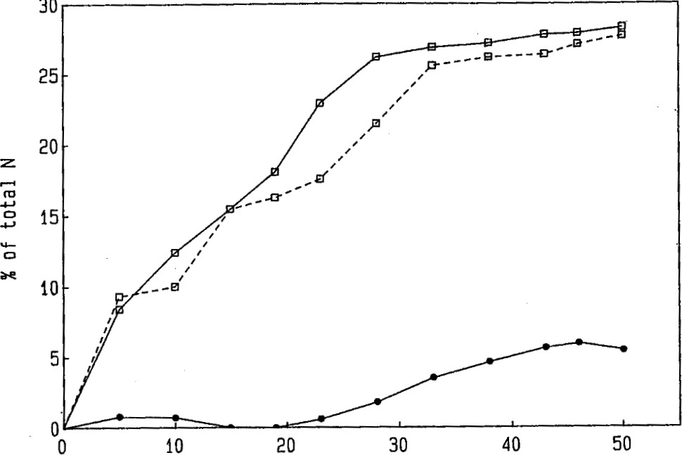
Days
Figure 1. Release of NHGN (a) and NON ( • ) from fresh green Azolla in moist (—) and flooded (---) soil.
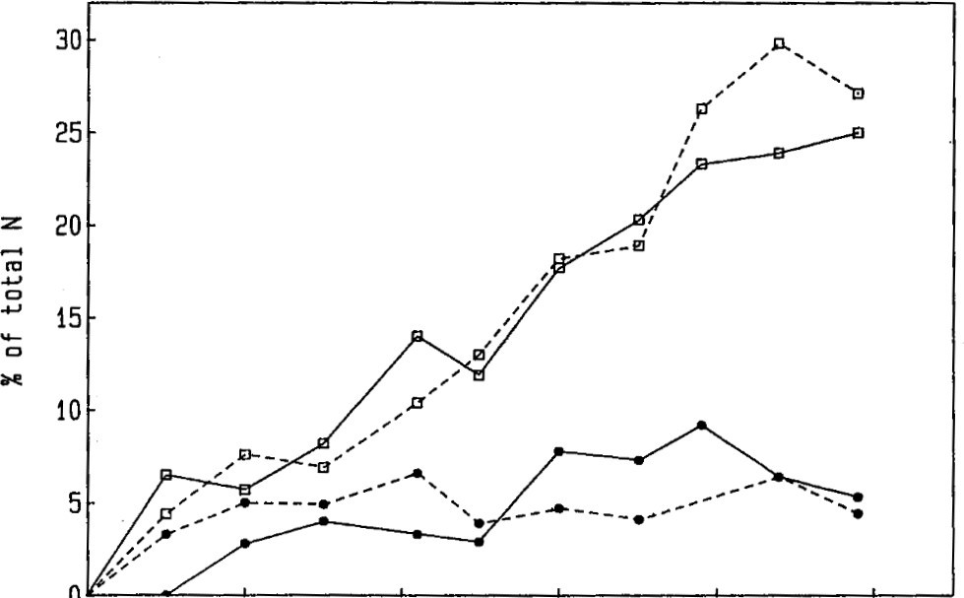
0
0 10 20 30 40 50
Days
Figure 2. Release ofNH4-N (a) and N03( • ) from fresh red Azolla in moist ) and flooded (---) soil.
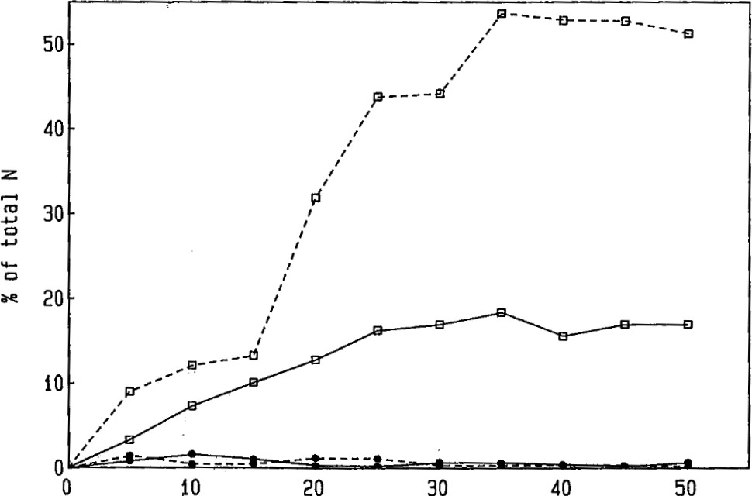
Days
Figure 3. Release ofNH4 (a) and NO3 ( • ) from dried Azolla in moist) and flooded (---) soil.
Table 1. Growth, grain and straw yield ofrice plants inoculated and not inoculated with fresh Azolla All the tanks were fertilized with 20:20:20 kg ha-I NPK 2-3 days before rice plants were transplanted. Azollawas inoculated in a single application a day before transplanting except for the 225g green Azolla which was incorporated in 2 equal split applicaüons a day before transplanting and at 4 weeks after transplanting. Control tanks received a second NPK application at week 4 after transplanting. Values given are mean ± standard error.
Treatment | Maximum height(cm) tiller no. |  | Grain yield | Straw yield
Control  +green Azolla  (225 g/tank)  Control  + green Azolla  (360 g/tank) | 80.5±5.1  82.4±6.3  74.5±7.0  84.5±6.5 | 9.0±1.4  9.1±1.6  8.1±0.2  6.0±0.5 | 63.4±0.2  77.1± 1.0  29.3±10.8  66.3± 8.8 | 80.9±0.9  85.6± 6.1  70.8±6.25  88.5± 5.5
Control  + red Azolla  (360 g/tank)  + red Azolla  (720 g/tank) | 72.5±5.0  72.5±5.8  79.2±4.5 | 11.4±2.8  12.9±2.4  10.5±2.3 | 23.3±6.9  28.0±14.7  33.3±10.7 | 105.7±4.5  106.2± 4.8  108.7±11.4
Table 2. Growth, grain and straw yield of rice inoculated and not inoculated with dried Azolla Azolla was introduced in three split applications (20:10:7.5 g for 37.5 g and 40:20:15 g for 75 g treatment) one day before and 5 and 11 weeks after of rice. Control tanks receivèd kg ha •l NPK one day before transplanting of the rice plants and two further applications of 20: 10: 10 kg ha-I NPK at the times specified above. Values given are mean ± standard error.
Treatment | Maximum height(cm) | tiller no. | Grain yield | Straw yield
+37.5 g Azolla  +75 g Azolla | 100.8±3.0  95.3±7.9  97.8±4.1 | 8.3±1.7  8.5±1.1  8.7±1.2 | 120.2±0.2  121.4± 7.0  133.8± 2.5 | 123.3± 5.9  102.9± 8.4  99.3±15.2



tion as well as the total release of N from Azolla are dependent on the physiological state of the fem and the conditions under which decomposition occurs. Generally, release of N is faster in vigorously-growing fresh fronds than in dried or slow-growing plants with lower water content. However, in contrast to published reports of reduced release of ammonia from dried than from fresh Azolla [4], we find that N mineralization of dried fronds is greatly enhanced under flooded conditions where about 50% of the total N of Azolla are readily converted to ammonium-N. That the released N can be utilized by rice plants is clearly demonstrated by the comparable growth as well as the similar and even enhanced rice yield of plants fertilized by basal application ofAzollacompared to controls that have received NPK supplements. Hence our results clearly show that Azollacould substitute effectively for mineral fertilization and that it is possible and perhaps more convenient to use dry Azolla plants as a basal fertilizer in rice cultivation.
Acknowledgments TheauthorwishestothankPuanBariahOthman for her very able technical assistance. The research is supported by an RPA (Nom -04-07-006).
REFERENCES
- Liu C.C. (1979) Use of azolla in rice production in China. In: Nitrogen and Rice pp. 375-394. Los Banos, IRRI.
- Singh PK. (1979) Use of azolla in rice production in India. In: Nitrogen and Rice pp. 407-418. Los Banos, IRRI.
- Talley S.N. and Rains D.W. (1980) Azollafiliculoides Lam. as a fallow season green manure for rice in a temperate climate. Agron.J. 72 11-18.
- Achtnich W., Moawad A.M. and Johal C.S. (1986) Azolla, a biofertilizer for rice. Intern. J. Trop. Agric. IV: 188-211.
- Brotonegoro S. and Abdulkadir S. (1978) The decomposition of Azolla pinnata in moist and flooded soil. Ann. Bogorienses 6: 169-17
- Ito O. and Watanabe I. (1985) Availability to rice plants of nitrogen fixed by Azolla. Soil Sci. Plant Nutr. 31: 91-104.
- Bremer J.M. (1966) Inorganic forms of nitrogen. In: Methods ofSoil Analysis. Part 2. Chemical and Microbiological Properties (ed. C.A. Black) pp. 1179-1237. Madison, Am. Soc. Agron. Inc.
- Cawse P.A. (1967) The determination of nitrate in soil solutions by ultraviolet spectrophotometry. Analyst 92: 311-315.
- Tung H.F. and Shen T.C. (1985) Studies of the Azolla pinnata Anabaena azollae symbiosis: Concurrent growth of Azolla with rice. Aquatic Botany 22: 145-152.
- Watanabe 1., Espinas C.R., Berja N.S. and Alimagno B.V. (1977) Utilization of the Azolla-Anabaena complex as a nitrogen fertilizer for rice. IRRI Research Paper Series No. 11.

